Attachment Physical Education Course Guide

I. Course Introduction

(I) Course Objectives
The physical education course is guided by the principle of "student exercise first," focusing on improving graduate students' physical fitness and sports skills through diverse sports programs and instructional teaching, helping students develop scientific exercise habits and achieve physical and mental health.
Course Programs and Content: Basic physical fitness, fitness running, ball sports, fitness, martial arts, and dancesport training, among others. Fitness running focuses on comprehensively enhancing students' cardiorespiratory function, endurance, strength, and flexibility through running, strength training, and flexibility exercises; ball sports—including basketball, volleyball, and tennis—cover the rules of the game, tactical skills, and methods of team coordination; dancesport emphasizes posture correction and the cultivation of poise, helping students develop a graceful physique. ​
The course has distinctive features and adopts a teaching model that integrates theory with practice, explaining exercise principles and health knowledge while emphasizing practical training. In addition, tiered instruction is implemented based on students' physical fitness and interests to meet the learning needs of students at different levels. Moreover, the course offers on-campus sports events and activities, providing students with a platform to showcase their athletic talent and creating a vibrant sports atmosphere.

(II) Credit Requirements
The required physical education course is worth 2 credits. Students may obtain the credits by successfully completing the course in any semester in accordance with the requirements.

II. Course Arrangement
(I) Time Slots and Specific Course Arrangements

Morning: 7:00-8:30 for physical training courses
Morning: 8:00-9:30 (1-2 sessions) and 9:50-11:30 (3-4 sessions) for technical individual courses

(The class schedule information below is for reference only; for accurate information, please refer to the notices on the Physical Education Institute website.)
Class  Time | Monday | Tuesday | Wednesday | Thursday | Friday | Remarks
7:00-8:30 | Fitness running (2.5-3 km)  300 people,  Qu Yansheng | Fitness running (2.5-3 km)  300 people,  Qu Yansheng | Fitness running (2.5-3 km)  300 people,  Qu Yansheng | Fitness running (2.5-3 km)  300 people,  Qu Yansheng | Fitness running (2.5-3 km)  300 people,  Qu Yansheng | 1) Total capacity: 3400 people;  2) Dancesport, fitness, basic physical fitness, fitness running, and basketball are offered as large-group classes.
8:00-9:30 | Basic physical fitness  200 people  Zhu Minhong  Basketball  100 people  Li Zengqiang  Volleyball  80 people  Shen Jiaxin | Volleyball  80 people  Qu Yansheng  Basic physical fitness  200 people  Zhu Minhong | Tennis  50 people  Wang Rui  Basketball  100 people  Li Zengqiang | Tennis  50 people  Wang Rui | Basketball  100 people  Li Zengqiang  Basic physical fitness (doctoral students only)  300 people  Yi Shuxian
9:50-11:30 | Fitness  80 people  Liao Zhijun | Fitness  80 people  Liao Zhijun  Dancesport  150 people  Wang Yan | Dancesport  150 people  Gao Ming | Frisbee  100 people  Chen Kai  Volleyball  80 people  Ren Wanlan

(II) Class Venues
Xipu Campus programs:
Program | Venue | Program | Venue
Fitness running | North Area Track | Basic physical fitness (doctoral students only) | North Area Track and Field Stadium

Jiuli Campus programs:
Program | Venue | Program | Venue
Fitness running | Track | Basic Physical Fitness | Track and Field Stadium
Volleyball | Volleyball Court | Basketball | Basketball Court
Tennis | Tennis Court | Fitness | Track and Field Stadium
Dancesport | Right side of the Track and Field Stadium, near the horizontal bar area | Frisbee | Track and Field Stadium

III. Course Selection and Instructions
(I) Steps of selecting PE
Step 1: Be sure to register for courses in the Graduate Student Management Information System between 9 a.m on September 12 and 18 p.m on September18 to ensure you are eligible to participate in the sports programs. Master's students must select a class at the Jiuli Campus; doctoral students may choose a class at either the Xipu Campus or the Jiuli Campus.
Step 2: Be sure to select sports programs on the Lejian app between 9 a.m on September 21 and 18 p.m on September25.
Note: After the course selection system opens in Week 4, if the fitness running classes at the Xipu Campus have not reached capacity, master's students may choose to enroll in the fitness running classes there.
(II) Steps of selecting programs on Lejian app
On the Lejian app, students can independently select sports programs based on their interests, familiarity, and course times, and after completing course selection, refresh the page to confirm that the selected course information is consistent. The specific operation instructions are as follows:
1. Install and activate the Lejian app
You can install the app by scanning the QR code or searching for "Lejian Sports" in the mobile app market. After new students install the app, please select "New User Activation":


- Choose "Student" as your identity and click "Next";
- Enter your phone number, obtain a verification code, agree to the "User Service Agreement" and "Privacy Policy," then click "Next";
- Select "School"—Southwest Jiaotong University, enter your student ID, name, set a new login password, and click "Activate" to use it normally.
- Since student information comes from the course selection list exported by the Graduate Student Management Information System, if activation fails, please confirm whether you have successfully selected courses in the Graduate Student Management Information System. If you have already selected courses, but the app still prompts activation failure, there may be a system delay. Please try again later.
Please refer to the diagram below for the specific process.
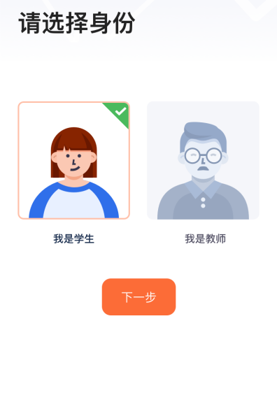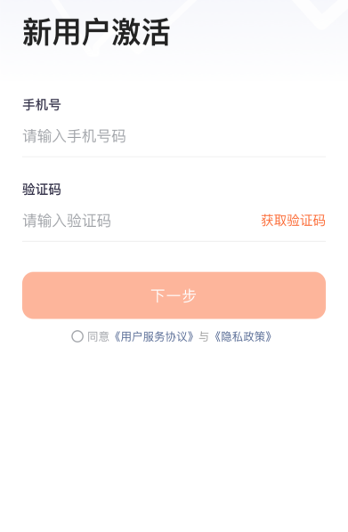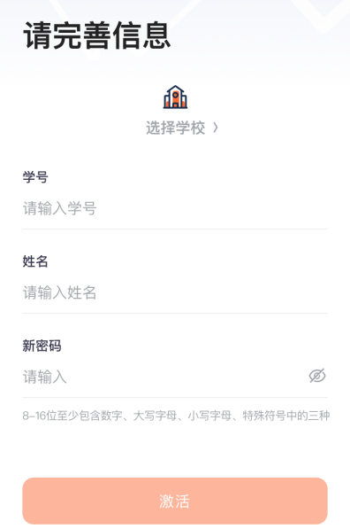
Reminder: All new students should keep passwords secure to avoid forgetting them. If you forget your password, please use the phone number for activation to receive a verification code for modification. If you need to change that phone number, please contact customer service within the Lejian app for assistance.
- Course Selection Process on the Lejian App
First, verify your personal information, such as student ID, name, semester, etc., to ensure accuracy; if there are issues, please contact online customer service. Next, on the app's homepage, select "2026 Physical Education Course Selection" to start course selection and then follow the prompts. Specific operations can be seen in the diagram below.

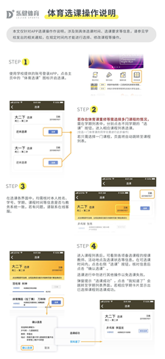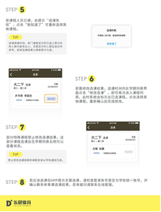

Once you enter the course list, you can see information about the instructors for each sports course, the class locations, and the course selection status. During the course selection period, click the "Select Course" button, verify the information, and then click "Confirm Course Selection."
A pop-up will appear saying "Course Selection Successful"; click "I Know" to be redirected to the semester list interface. If the selected courses are displayed for the corresponding semester, it means that the course selection is successful.
If the number of participants for any selected course is full, a message will appear saying "Course Selection Failed"; click "I Know" to reselect other courses.
If you need to modify your course selection results, please click "Modify Course Selection" in the semester list interface during the designated course selection period to re-enter the course list. The system will indicate the courses you have already selected. Click to choose other courses, and after reconfirmation, the modification will be completed.

